Contribution Title
First Author¹[0000-1111-2222-3333] and Second Author²[1111-2222-3333-4444]
¹ Princeton University, Princeton NJ 08544, USA
² Springer Heidelberg, Tiergartenstr. 17, 69121 Heidelberg, Germany
lncs@springer.com
Abstract. The abstract should summarize the contents of the paper in short terms, i.e. 150-250 words.
Keywords: First Keyword, Second Keyword, Third Keyword.
- Introduction
  - Introduction to Project Fieper
FIEPER, also known as Field Operator Robot is an Operations Assistive Robot that is designed keeping in mind the tasks it has to carry out while being deployed in process industries replacing the human workforce where the tasks otherwise might risk their health and safety. The main aim of Project FIEPER is to take this abstract idea, come to a logical conclusion, and as a result, set up a goal to work towards an end-to-end design, making a working prototype and finally implementing a full – fledged working model of an unmanned ground vehicle to replace the human workforce in such hazardous and dangerous environments.
  - Project Lunokhod
The name ‘Lunokhod’ was inspired by the Soviet Lunokhod robotic lunar rovers. Project Lunokhod is the implementation of this ideal portrayed by FIEPER. Lunokhod is a warehouse intelligent robot conceptualized to carry out various tasks. It is an unmanned ground vehicle with a robotic manipulator on the top for pick and place operations. It will be of great help in places where risk may be involved if the task was to be handled by human workforce and even in cases where the payload is too large for any person to handle it by themselves. This will also ensure fast and efficient work flow in the place of implementation. The Lunokhod robot will find multiple uses and will be able to execute tasks in warehouses or even factory assembly lines in some cases.
- Mechanical
  - Manipulator
To enhance the usability of the Lunokhod rover, a robotic manipulator is placed on top of the chassis to aid the rover in pick and place operations.

Construction. The manipulator is constructed in such a way that it has 5 degrees of freedom, hence, giving it more flexibility in utilizing its workspace more effectively and efficiently. There are a total of three links each connected to the each other with a revolute joint. The first link is connected to the base also with a revolute joint.
The base can revolve as it is connected to a fixed base plate with the help of a revolute joint. This revolving base is then mounted on top of a fixed base plate which is then mounted on top of the chassis.
The criteria for choosing the material had to satisfy the requirements such as high strength and lightness. As a result, we have chosen carbon fiber as the required material for the body and links of the manipulator. Carbon fiber offers high strength and rigidity and helps a lot in weight reduction and satisfies our requirements. Thus, this reduces the load on the motors for the manipulator and also has a higher bending moment. Hence, heavier payloads can be handled more easily without causing failure to the operation of the manipulator during picking and placing of the payloads.

Fig. . Manipulator assembly

End-effector. We are using two grippers, specifically the MHM-50D2-M9B magnetic gripper as the end-effector for pick and place operations.
Heavy payloads, ideally ferromagnetic in nature which have to generally be handled in warehouses by manual labor can be done so with ease with the help of Project Lunokhod. The grippers have a mount which is connected to the third link with a revolute joint for it to rotate. As a result, we can obtain many different orientations for the end-effector.

Working. The principle that this gripper follows is that when magnetization takes place, a magnetic force is released. In our case, the end-effector has an integrated permanent magnet which acts as a core through which a sufficient amount of current is passed. Hence, magnetization takes place and a magnetic field is developed because of which ferromagnetic objects can get attracted. Further, there are two pneumatic ports, one for inlet and the other for outlet to aid in the movement of the magnet. When compressed is passed into the inlet port, the magnet acts as a piston and extends further out from the end-effector and when the air is taken out, the magnet goes back to its original position. Thus, this increases the reach of the magnetic end-effector.

D-H Parameters and Inverse Kinematics
Fig. . Frame assignment

n | $$θ_{n}$$ | $∝_{n}$(degrees) | $r_{n}$(m) | $d_{n}$(m)
1 | $$θ_{1}$$ | 0 | 0 | 0.070902
2 | $$θ_{2}$$ | 90 | 0 | 0.04340
3 | $$θ_{3}$$ | 0 | 0 | 0.153254
4 | $$θ_{4}$$ | 0 | 0 | 0.1309
5 | $$θ_{5}$$ | 90 | 0.104036 | 0

To calculate the D-H Parameters, the model was opened on Fusion 360 and a diagram for frame assignment was made as shown above. Then, using the inspect tool, the exact distances were measured from the CAD model and entered into the table.

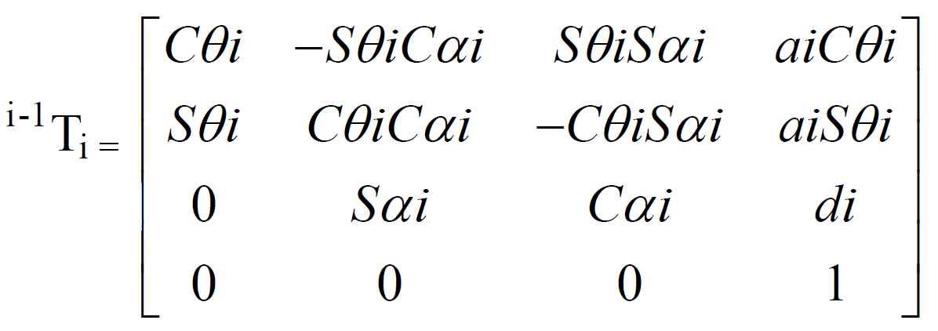

where, Sθi=sin θi, Cθi =cos θi, Sα i=sin α i, Cαi=cos αi, Sijk=sin(θ i+ θj+ θk), Cijk=sin(θi+ θ j+ θk)

The values of the variables in the matrices can be obtained from the D-H Parameter table above.

$$0T5=\left[\begin{matrix}C12*C345 & S12 & C12*S345 & S12*d5+C12*a4*C34+C12*a3*c3 \\ S12*C345 & -C12 & S12*S345 & -C12*d5+S12*a4*C34+S12*a3*C3 \\ S345 & 0 & -C345 & a4*S34+a3*S3+d1 \\ 0 & 0 & 0 & 1\end{matrix}\right]$$

Multiplying all the individual transformation matrices as shown below and solving,
Te = 0T1* 1T2* 2T3* 3T4* 4T5 = 0T5
We get the final theta values as:
θ1 = θ12 - θ2
θ2 = tan-1(py/px)
θ3 = tan-1 (s3/c3)
θ4 = tan-1 (s4/c4)
θ5 = θ345 - θ34 where θ345 = tan-1{(-az)/(c2*ax+s2*ay)}, θ34 = - tan-1{(c12*px+s12*py)/pz}

  - Wheels
Project Lunokhod uses meccanum wheels mounted on all four motors to enhance its maneuverability which would be helpful in navigating in small and tricky workspaces in the warehouse environment it is deployed.

Construction. The meccanum wheel has a radius of 45mm and a width of 21mm. The core of the wheel structure is similar in shape to a pentagon with each vertex extended out and filleted which is made of ABS plastic. This ensures that there is less rotating mass which aids in reducing the load on the motor and can hence, can increase the efficiency of the operation.
Five rollers made out of Butyl Rubber which has coefficient of friction of 0.6 on dry concrete are placed between the extended vertices and are connected to the core with a revolute joint. Hence, each roller is free to revolve around its own axis. The main objective of this roller is to enhance the maneuverability. Since, the Lunokhod chassis will use differential drive for maneuvering around, each wheel will rotate at different speeds with respect to each other. This causes the roller to start revolving and moves chassis more to the left or right direction depending on the relative motion between the wheels.
Each motor has two meccanum wheels mounted on it. Both are mounted in such a way that there is difference in the orientation on their own axis by an angle of 35 degrees. In this particular orientation, when the roller of one wheel is in contact with the floor surface, the edge of the core of the other wheel is in contact with floor surface. Hence, with the help of this, when the core is in contact and the wheel is rotating, it aids in moving the chassis in the forwards and backwards directions whereas, when the roller is in contact with the surface, it aids in moving the chassis in either the left or right directions. This changes alternatively between the two wheels as they are rotating with the help of the torque produced by the motor.
  - Chassis
The chassis is one of the most fundamental parts for the AGV as it provides it with a structural framework and allows for the mounting of peripherals, sensors, motors, wheels etc. It is of paramount importance that it be designed in a way that is structurally sound while keeping its application in mind. The two main caveats while designing the chassis are: shape and material used.
The shape of the chassis can vary according to the application/other design considerations and constraints that may exist. The material can vary according to the application, cost, and availability.

Shape. The chassis has been designed as a hollow cuboid. This is the fundamental structure to which we have added members as per our requirements.
There is one central platform which is supported by cross members along the diagonals from below for structural support and load distribution. This platform is meant for the mounting of the manipulator for the pick and place operations within the warehouse.
There is another platform right below it. Vertical rectangular members run from the upper surface of the lower platform to the lower surface of the upper platform for further structural support and rigidity. The lower platform is where the RPi, Arduino, and the batteries will be placed. The batteries are heavier components and so help in lowering the centre of gravity as the platform is on a relatively low level in the chassis. The components are protected by the platform above and so this arrangement serves a dual purpose- structural soundness and safety of the electronic and electrical components housed.
There are two platforms- rear and front- for the mounting of the motors. A support structure has been created to hold the motor in place. The space between the motor has been utilized to mount the motor driver which drives two motors simultaneously.
The edges in the load bearing areas have been filleted with a 10 mm radius rolling ball type fillet to make sure there is no stress concentration at a sharp edge.
The relevant dimensions for the chassis are given below:
- Outer length: 750mm
- Outer breadth: 550mm
- Inner length: 670mm
- Inner breadth: 470mm
- Outer fillet radius: 40mm
- Inner fillet radius: 40mm
- Height: 210mm
- Thickness of manipulator platform: 55mm
- Thickness of motor platforms: 8.222mm

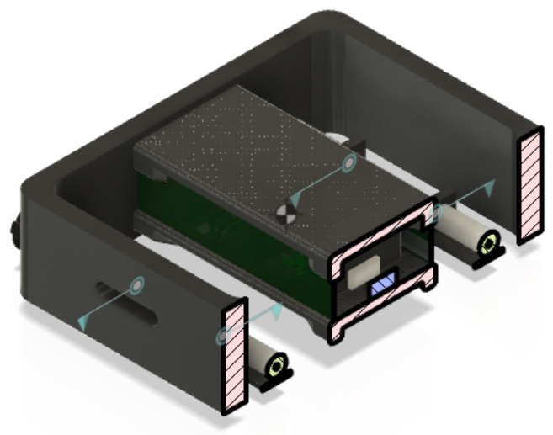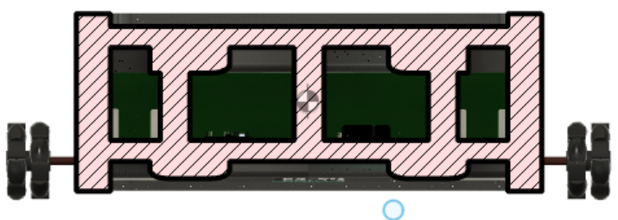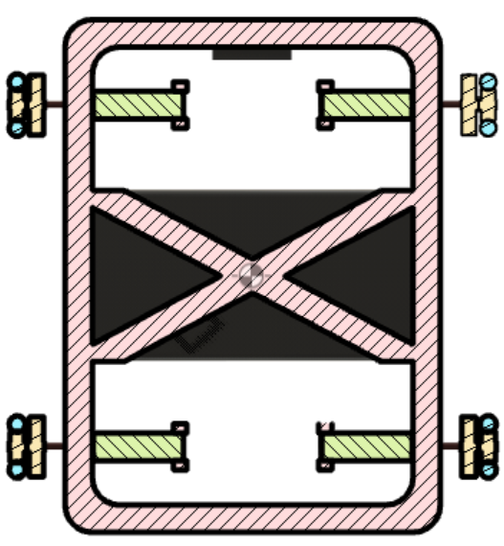
Fig. . Sectional views of the chassis

Material used. The following materials were taken into consideration for the chassis build:
- Carbon Fibre Reinforced Polymer
- ABS Plastic
- Aluminium 7075

Due to the nature of the design, all the three materials were able to withstand the applied load of 1200 N on the top platform. The vertical members (especially the one in the centre) were useful in preventing bending of the platform on the application of the load by distributing it.

Carbon Fibre Reinforced Polymer . CFRP is known for its high Young’s Modulus (133 GPa), high yield strength and high ultimate tensile strength. It is lightweight and helps in strengthening of structures. It is more expensive, relatively, but doesn’t incur a significant increase in cost.
After carrying out the Von Mises stress analysis on Fusion 360, we decided to go ahead with Carbon Fibre Reinforced Polymer. It could withstand a load of $2.1 × {10}^{6}$ N of force and because:
- The maximum stress on the motor shafts is less than half of that of ABS plastic.
- It has high Young’s Modulus and so it does not deform easily when subjected to loads.
- It is light and so the torque requirement for the motor is less.

ABS Plastic. ABS plastic is light and one of the most rigid and tough thermoplastic available in the market. It is light in weight and can provide good enough yield stress, ultimate tensile strength, etc. and is inexpensive to buy and mold into shape.
After carrying out Von Mises stress analysis on Fusion 360, it could withstand a load of approximately $1.5 ×{10}^{5}$ N of force before structural failure and we thought that the structural material could improve because:
- The structure could hold well for lighter loads, but when the payload increased a bit, the structure was not able to withstand it and was causing it to bend and buckle from the middle and also added stress to the motor shafts causing them to bend.
- If the chassis is used in places where the ambient temperature is high and since ABS plastic has a low melting point, there is a high chance that it will start to melt and lose its structural integrity.

Aluminium 7075. Aluminium was our first selected material for study. Aluminium is a light and flexible but when constructed and shaped in a particular manner, can provide good enough structural integrity. It was able to withstand a force of 2000 kN before losing structural integrity. However, after the Von Mises stress analysis on Fusion 360, it could withstand a load of $2.0 × {10}^{6}$ N of force before breaking. It was still rejected because:
- Under heavier loads, there was failure of the Aluminium structure causing displacement of the shape of the chassis.
- They heavy weight of the chassis put stress on the shaft of the motor and caused it to bend.
- The chassis made from Aluminium was too heavy and was feasible to find a motor to find a really high torque output.

Aluminium 7075 was rejected as it made the chassis very heavy and it not feasible to find a motor to cater to such high torque requirements.
ABS Plastic was rejected as the stress on the motor shafts was maximum and could eventually lead to failure over the course of time.


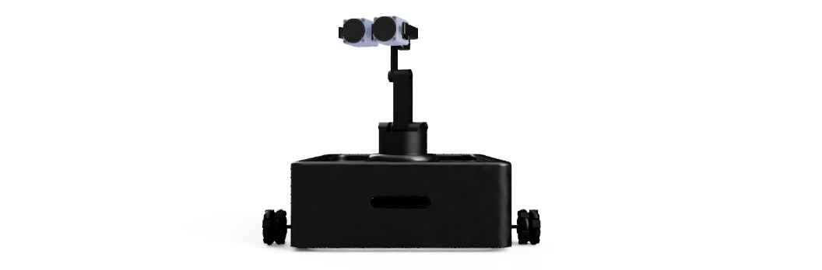


Fig. . Chassis with the mounted manipulator

- Motor
  - General Overview
As per the weight and requirements of our chassis, we will be using four DC planetary gear motor, specifically the PG56/63ZY125-2440-55k. It is compact and light weight motor with a high efficiency (about 97% as there is a 3% loss at each stage in the planetary gear train). A number of reduction gear ratios are available to increase the torque output, making it more versatile.
Thus, this motor is our pick for Project Lunokhod due to its load-carrying capacity, transmission precision and high efficiency. It also satisfies our minimum torque requirement of about 15 N.m by giving an output torque of 18 N.m if we use a reduction ratio of 55.

  - Construction and Mechanicals
This motor has dimensions of 25 x 7 x 7 cm and a weight of 2.224 kg. The housing material is made out of steel whereas the gears are made out of Steel, sometimes powdered or even Polyoxymethylene. As a result, the strength is high. The planetary gearbox is compact and light in weight.
The motor has a rated output torque of 450 mN.m, but with the planetary gearbox having a reduction gear ratio of 55, we get a rated output torque of 18 N.m. Hence, we’ll be using four of such motors to generate enough torque to handle the weight of the whole chassis including the weight of the arm assembly and the electronic components. It has a stall torque of 1200 nN.m.
This particular model of the dc motor can have a rated speed of 3200 r/min and a no-load speed of 4000 mN.m which is relatively low, which is a trade-off for a higher torque output which is our main priority.

  - Supply, motor Equation and working
The motor works with a supply dc voltage of 24V. It has a stall current and no-load current of 22.5 A and 1.2 A respectively. The rated power of the motor is 150W. A magnetic field is developed by a permanent fixed magnet. A rotating armature through which a current flows, passing through this magnetic field at right angles and faces a force, $F=Bli_{a}(t)$. A voltage at the terminals of the conductor is developed which is $e=Blv$. The current-carrying armature is rotating in a magnetic field, its voltage is proportional to speed. Hence,
$v_{b}\left(t\right)= K_{b}\frac{dθ_{m}(t)}{dt}$ (1)
The back emf constant $K_{b}$ has a value of 0.001. Hence, substituting in equation (1),
$v_{b}=0.001\frac{dθ_{m}(t)}{dt}$ (2)
Taking Laplace transform, we get
$V_{b}\left(s\right)= K_{b}sθ_{m}(s)$ (3)
Substituting the back emf constant,
$V_{b}\left(s\right)=0.001sθ_{m}(s)$ (4)
Writing a loop equation around the Laplace transformed armature circuit,
$R_{a}I_{a}\left(s\right)+ L_{a}sI_{a}\left(s\right)+ V_{b}\left(s\right)= E_{a}(s)$ (5)
The armature resistance of the motor is 0.3 ohms.
$0.3I_{a}\left(s\right)+ L_{a}sI_{a}\left(s\right)+ V_{b}\left(s\right)= E_{a}(s)$ (6)
Torque of the motor is proportional to the armature current. Hence,
$T_{m}\left(s\right)= K_{t}I_{a}(s)$ (7)
Rearranging equation (7), we get
$I_{a}\left(s\right)= \frac{1}{K_{t}}T_{m}(s)$ (8)
$K_{t}$ is the constant of proportionality, i.e., the torque constant. Substituting this value in equation (8),
$I_{a}\left(s\right)= \frac{1}{0.015}T_{m}(s)$ (9)
We substitute equations (3) and (8) into (5), we obtain
$\frac{(R_{a}+ L_{a}s)T_{m}(s)}{K_{t}}+ K_{b}sθ_{m}\left(s\right)= E_{a}(s)$ (10)
$\frac{(0.3+ L_{a}s)T_{m}(s)}{0.015}+0.001sθ_{m}\left(s\right)= E_{a}(s)$ (11)
$J_{m}$ is the equivalent inertia at the armature and $D_{m}$ is the equivalent viscous damping at the armature. From the motor, we obtain the following equation,
$T_{m}\left(s\right)= {(J}_{m}s^{2}+ D_{m}s)θ_{m}(s)$ (12)
As per the mechanical characteristics of the motor, the value of $J_{m}$ is xx and the value of $D_{m}$ is 0. Using this in equation (11), we get
$T_{m}\left(s\right)=(10s^{2})θ_{m}(s)$ (13)
Substituting equation (12) into (10), gives us
$\frac{\left(R_{a}+ L_{a}s\right)(J_{m}s^{2}+ D_{m}s)θ_{m}(s)}{K_{t}}+ K_{b}sθ_{m}\left(s\right)= E_{a}(s)$ (14)
$\frac{(0.3+ L_{a}s)(xxs^{2})θ_{m}(s)}{0.015}+0.001sθ_{m}\left(s\right)= E_{a}(s)$ (15)
Assuming that the armature inductance is small compared to its resistance, equation (14) becomes,
$\left[\frac{R_{a}}{K_{t}}\left(J_{m}s+ D_{m}\right)+ K_{b}\right]sθ_{m}\left(s\right)= E_{a}(s)$ (16)
$\left[200s+0.001\right]sθ_{m}\left(s\right)= E_{a}\left(s\right)$ (17)
The desired transfer function, ${θ_{m}(s)}/{E_{a}(s)}$ is
$\frac{θ_{m}(s)}{E_{a}(s)}= \frac{{K_{t}}/{(R_{a}J_{m})}}{s\left[s+ \frac{1}{J_{m}}(D_{m}+ \frac{K_{t}K_{b}}{R_{a}}\right]}$ (18)
Using the values obtained and substituting in the equation,
$\frac{θ_{m}(s)}{E_{a}(s)}=\frac{0.005}{s\left[s+ 0.000005\right]}$ (19)
Consider a motor having an inertia and damping of $J_{a}$ and $D_{a}$ respectively driving a load consisting of an inertia $J_{L}$ and a damping of $D_{L}$ and can be reflected back to the armature as some equivalent inertia and damping to be added back respectively. Thus, the inertia $J_{m}$ and damping $D_{m}$ at the armature becomes
$J_{m}= J_{a}+ J_{L}{\left(\frac{N_{1}}{N_{2}}\right)}^{2}; D_{m}= D_{a}+ D_{L}{\left(\frac{N_{1}}{N_{2}}\right)}^{2}$ (120)
Substituting equations (3) and (8) into equation (5) and taking the value of $L_{a}$ as 0, we get
$\frac{R_{a}}{K_{t}}T_{m}\left(s\right)+ K_{b}sθ_{m}\left(s\right)= E_{a}(s)$ (21)
Using inverse Laplace transform
$\frac{R_{a}}{K_{t}}T_{m}\left(t\right)+ K_{b}ω_{m}\left(t\right)= e_{a}(t)$ (22)
The inverse Laplace transform in the above equation is $ω_{m}(t)$.
When a dc voltage of magnitude $e_{a}$ is applied, it causes the motor to rotate with an angular velocity and with a torque of $ω_{m}$ and $T_{m}$ respectively. Solving equation (22) by dropping the functional relationship based on time, we get
$T_{m}= - \frac{K_{b}K_{t}}{R_{a}}ω_{m}+ \frac{K_{t}}{R_{a}}e_{a}$ (23)
The stall torque of the motor $T_{stall}$ can be calculated as
$T_{stall}= \frac{K_{t}}{R_{a}}e_{a}$ (24)
The angular velocity at no-load speed when the torque is zero is,
$ω_{no-load}= \frac{e_{a}}{K_{b}}$ (25)
The electrical constants of the motor’s transfer functions can be obtained from equations (24) and (25). They are:
$\frac{K_{t}}{R_{a}}= \frac{T_{stall}}{e_{a}}$ (26)
and
$K_{b}= \frac{e_{a}}{ω_{no-load}}$ (27)
By solving all the equations above as per the specifics of the motor, we get the motor torque constant $K_{t}$ as 0.015, the back emf constant $K_{b}$ as 0.0001, inertia $J_{m}$ as 10 $kgm^{2}$ and damping $D_{m}$ as 0 (assuming no damping system). The armature resistance is 0.3 ohms.
  - Motor Torque, Sourcing and Script
The following script was written on MATLAB to get the values of the required torque and stall torque which we used to find a suitable motor for our application. Care was taken to make sure that the motor wasn’t excessively heavy and met the dimensional requirements according to the dimensions of the chassis.

Given Parameters.
no_of_wheels = 4;

vel = 1; % velocity in m/s
acc = 1; % accelaration in m/s^2

GVW = 60; % AGV weight in kg
payload = 12; % in kg

operating_temp = 0:40; % temperature range from 0-40 degree celcius
run_time = 12; % running time of AGV is 12 hours
charge_time = 4; % charging time og AGV is 4 hours
% Additional accessory - Mounting of GOERTZ 6 DOF Robot Arm and omni wheels
% for side traversal
no_of_motors = 4;
power_supply = 12:24; % 12-24 V at 10A
turning_radius = 0; % because of side traversal ability
grade = 0.5; % slope degree
wheel_rad = 45; % wheel radius is 45 mm
acc_time = 1:3; % accelaration time between 1 to 3 seconds
g = 9.81; % accelaration due to gravity in m/s^2
FOS = 2; % Factor of Safety

Motor Torque Calculation.
crr = 0.015; % surface friction for concrete surface
% Step 1 - finding rolling resistance
RR = GVW * crr * g;
fprintf("The rolling resistence, RR is %f kg m/s^2",RR);
% step 2 - finding grade resistance
GR = GVW * sin(grade) * g;
fprintf("Grade resistance, GR is %f kg m/s^2",GR);
% step 3 - finding accelaration force
FA = GVW * acc;
fprintf("The accelaration force, FA is %f kg m/s^2",FA);
% step 4 - finding total tractive force
TTE = RR + GR + FA;
fprintf("The total tractive force is %f kg m/s^2",TTE);
% step 5 - finding motor torque
motor_torque = TTE * (wheel_rad/1000);
fprintf("The motor torque for the required application is %f Nm",motor_torque)

Motor Torque – Relevant Torque Terms.
Stall Torque/Breakdown Torque
stall_torque = motor_torque * FOS;
fprintf('The stall torque is %f Nm',stall_torque)
jn

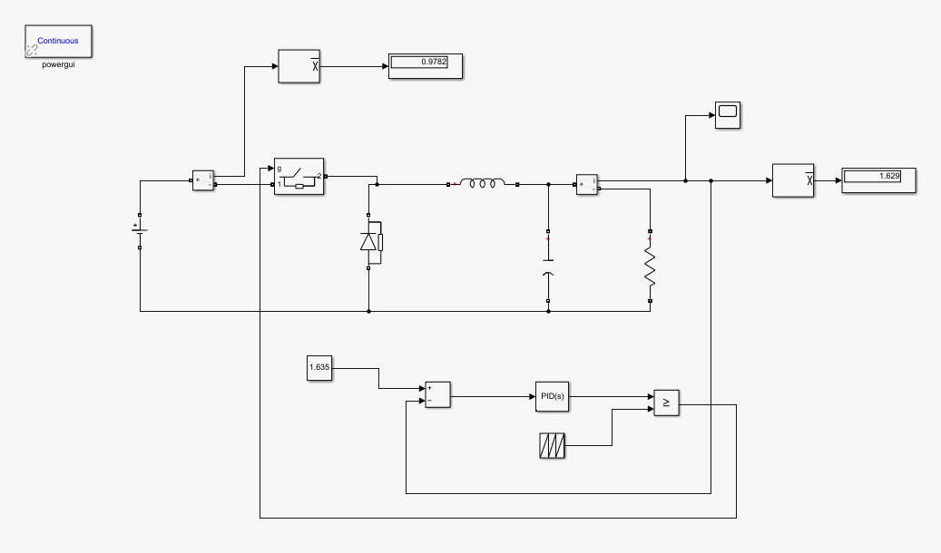
Fig. . Buck Converter to increase current to the End-Effector
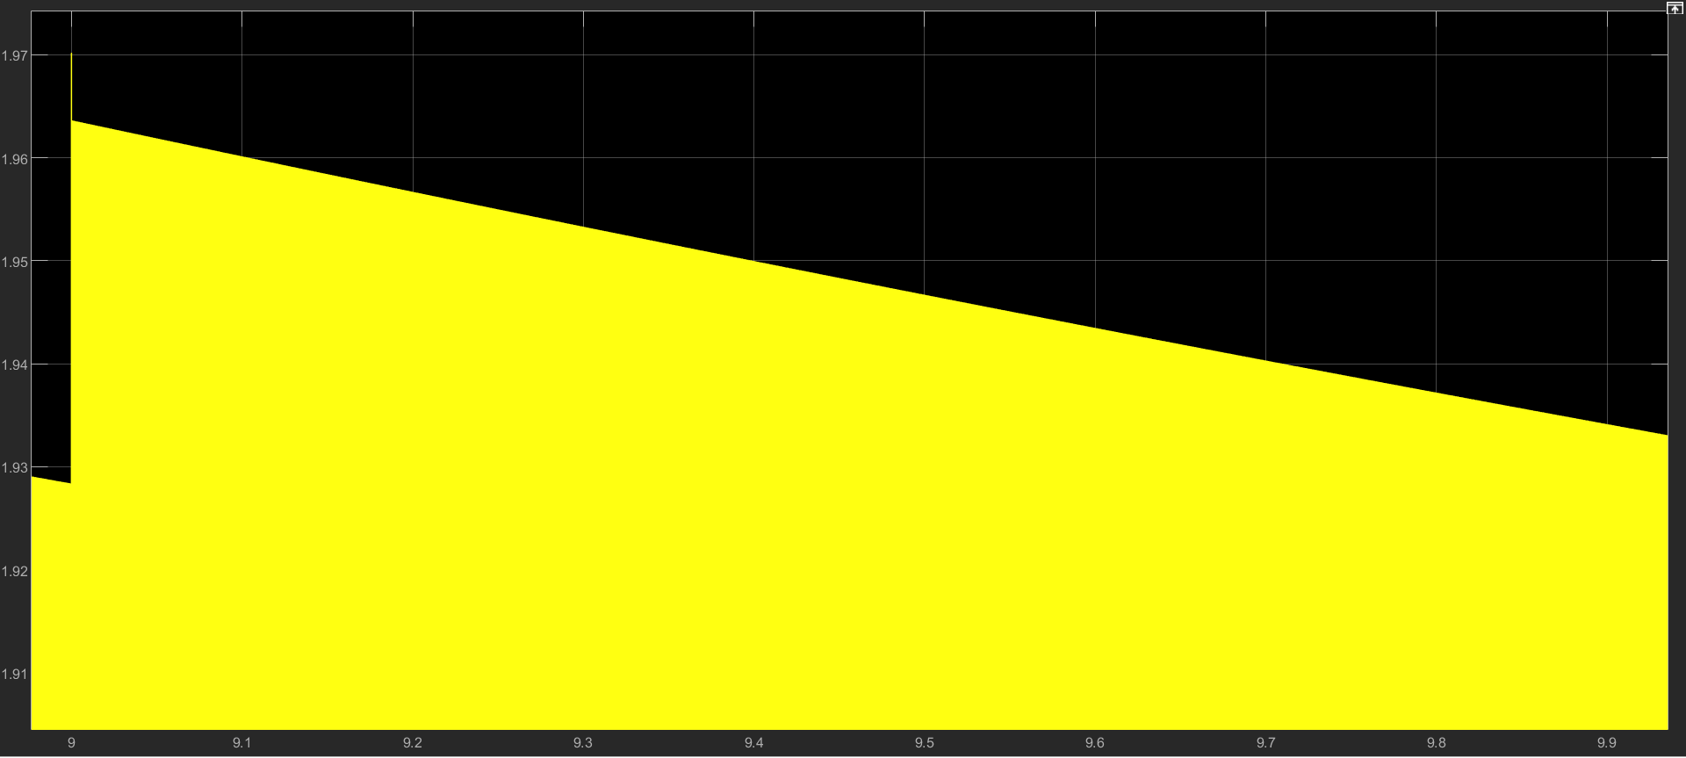
Fig. . Scope View for Current from t=9s to t=10s
Above, we have shown the circuit diagram for the Buck Converter along with the scope view for the simulation. The time was taken as 10s and here, we have shown the signal from t=9s to t=10s.
From the microcontroller, the current supplied is very less- in the order of milliamperes. Hence, we have used a Buck Converter which uses a PID controller to generate the gate pulses for the ideal switch. The Buck Converter reduces the voltage level that is received from the microcontroller (assumed to be 3.3V for the RaspberryPi) and consequently boosts the current. We require a current of around 1.633 A for our application and the current obtained after tuning is 1.629 A. The current is supplied to the electromagnets in the end-effector to power them. The current in mA would not have sufficed and so this circuit was used to boost the current to an ideal level.
To get the value of the current required, the following script was written on MATLAB. After obtaining this value, we tuned the Buck Converter accordingly.

SCRIPT FOR CURRENT CALCULATION
pi=3.14;
R=0.03525; %radius of the contact surface of the electromagnet
r=0.5; %resistance of the wire
N=1000; %number of turns/metre
A = pi*R*R; %area of the contact surface of the electromagnet
O = (2*pi*200)/60; %omega
K = (N*A*O)/r; %overall constant
B = i/K;
I = linspace(0,0.1,1000);
ireq = 0.01*K; %required current

SCRIPT TO OBTAIN GRAPHS FOR B vs I and H vs I
pi=3.14
mu0=(4*pi)*(10^-7);%Permeability Constant in N/A^2
I=0.005:0.05:100; %range of current values in A
r=0.01; %distance between magnetic surface and payload surface
N=100; %number of turns in the coil
L=0.3; %length of the coil in m
n=N/L;%number of turns/unit length
B=mu0*n*I;%Magnetic Flux Density in Tesla
figure;
plot(B,I);
title("B vs I");
ylabel('B');
xlabel('I');
H=I*n;%Magnetic Field Strength in A/m
figure;
plot(H,I);
title('H vs I');
ylabel('H');

- AI
- IOT
- Conclusion
Project Lunokhod implements the use of a manipulator for pick and place operations of the payload as well as using an Autonomous Guided Vehicle (AGV) for transporting the payload from one point in the warehouse or place of deployment to another. This ensures smooth flow in the supply management of the place. All this can be done autonomously without any external human help, though the option for human over-riding is always there for ethical concerns and certain extra-ordinary situations that may arise. It is an ideal solution to slow and inefficient warehousing.

